Mitigating Denial-of-Service Attack in SDN

Graduation project is submitted to Electronics and Communications Department in Partial fulfilment of the requirements for the Degree of Bachelor of Electronics and Communications Engineering

BY
Khaled Elsayed Ahmed

SUPERVISED BY
Prof. Ihab Abdelwahab Ali
Professor of Electronics and Communications Engineering
Faculty of Engineering, Helwan University

2024

Mitigating Denial-of-Service Attack in SDN
Khaled elsayed ahmed
motaweak226@gmail.com

ABSTRACT
The ever-increasing reliance on web servers necessitates strong security measures to counter Denial-of-Service (DoS) attacks. These attacks overwhelm servers with excessive traffic, making them unavailable to legitimate users. This paper proposes a system utilizing an SDN (Software-Defined Networking) controller application, implemented using a Python script, to mitigate DoS attacks on HTTP servers. The system leverages OpenFlow protocol communication with network switches to analyze incoming traffic and filter out malicious packets. The core functionality of the system resides within the Python script running on the SDN controller. This script focuses on two key approaches to protect the HTTP server:
- Rate Limiting: It tracks the number of incoming SYN packets (used for connection initiation) per second. If the rate surpasses a predefined threshold, the system identifies the traffic as a potential SYN flood attack and drops the packets
- Source IP Address Filtering (Access Control): The script allows traffic only from authorized IP addresses or subnets defined within the script itself.

KEYWORDS: DoS attack, SDN, OpenFlow, Rate Limiting, Access Control, SDN Controller, Python Script, HTTP server, Network Security, Flow Monitoring, Packet Filtering

INTRODUCTION
The internet has a strong effect on how we live, work, and interact. From online banking and e-commerce to social media and streaming services, web servers play a critical role in supporting these essential activities. These servers store and deliver web content to users globally, ensuring the smooth operation of the online systems. However, a significant threat exists to these systems: Denial-of-Service (DoS) attacks.
DoS attacks aim to affect one of the most important security concepts which is availability by overwhelming them with excessive traffic. This makes the server inaccessible to users, potentially causing significant financial losses, reputational damage, and service outages for businesses and organizations. DoS attacks can take various forms, from simple flooding techniques to more complicated distributed attacks (DDoS) involving botnets of compromised devices. Regardless of the method, the goal remains the same , to hinder a server's ability to function effectively.
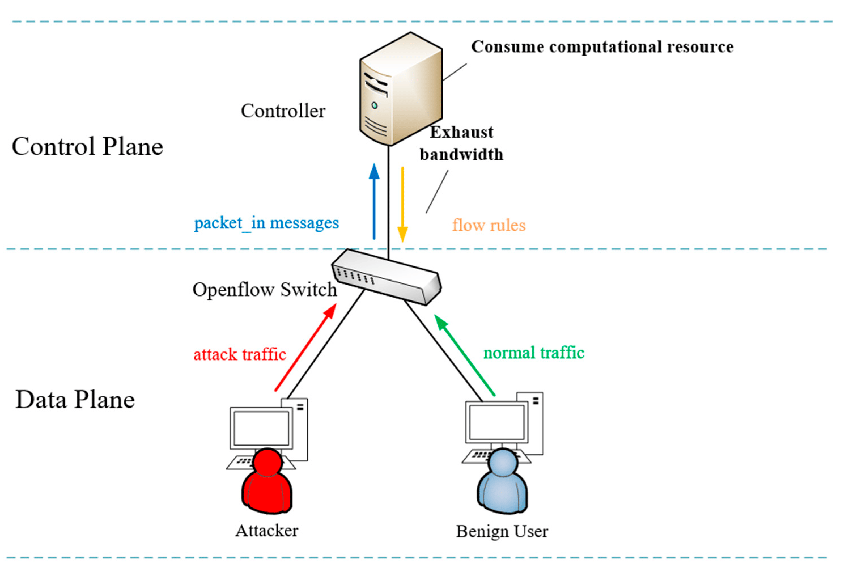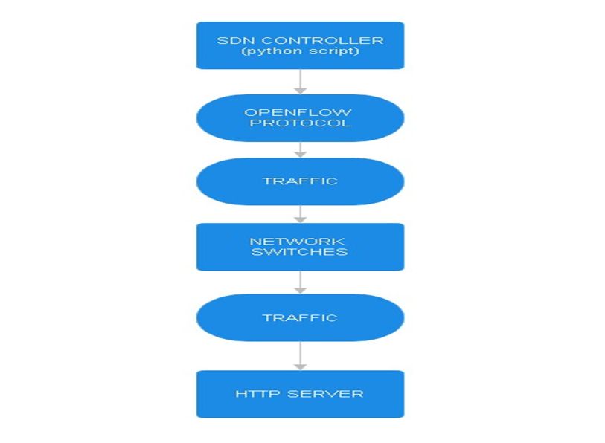
This paper proposes a novel approach to mitigating DoS attacks on HTTP servers. We present an SDN-based system utilizing a Python script for rate limiting and access control. Software-Defined Networking (SDN) offers a more centralized and programmable approach to network security. By leveraging an SDN controller and a custom Python script, we can create a dynamic and adaptable system that can analyze and filter incoming traffic in real-time, focusing on identifying and mitigating DoS attacks before they impact legitimate users.

the proposed system
This paper proposes a system utilizing an SDN (Software-Defined Networking) controller application, implemented using a Python script, to mitigate DoS attacks on HTTP servers. It focuses on identifying and dropping SYN flood attacks while permitting legitimate traffic from authorized subnets. This approach offers a more adaptable and dynamic defence mechanism compared to traditional network security solutions.
Here's a breakdown of the key components:
- SDN Controller: This central entity acts as the brain of the system. It runs the Python script for rate limiting and access control functionalities. Additionally, the controller communicates with network switches using the OpenFlow protocol to configure their behaviour and enforce security policies.
- OpenFlow Protocol: This communication protocol serves as the language between the SDN controller and network switches. It allows the controller to dynamically configure the switches' forwarding tables, instructing them on how to handle different types of traffic based on pre-defined rules within the Python script.
- Python Script (Rate Limiting and Access Control Application): This software module, residing on the SDN controller, is the heart of the mitigation strategy. The python script analyses incoming traffic characteristics and enforces security policies defined within the script itself.
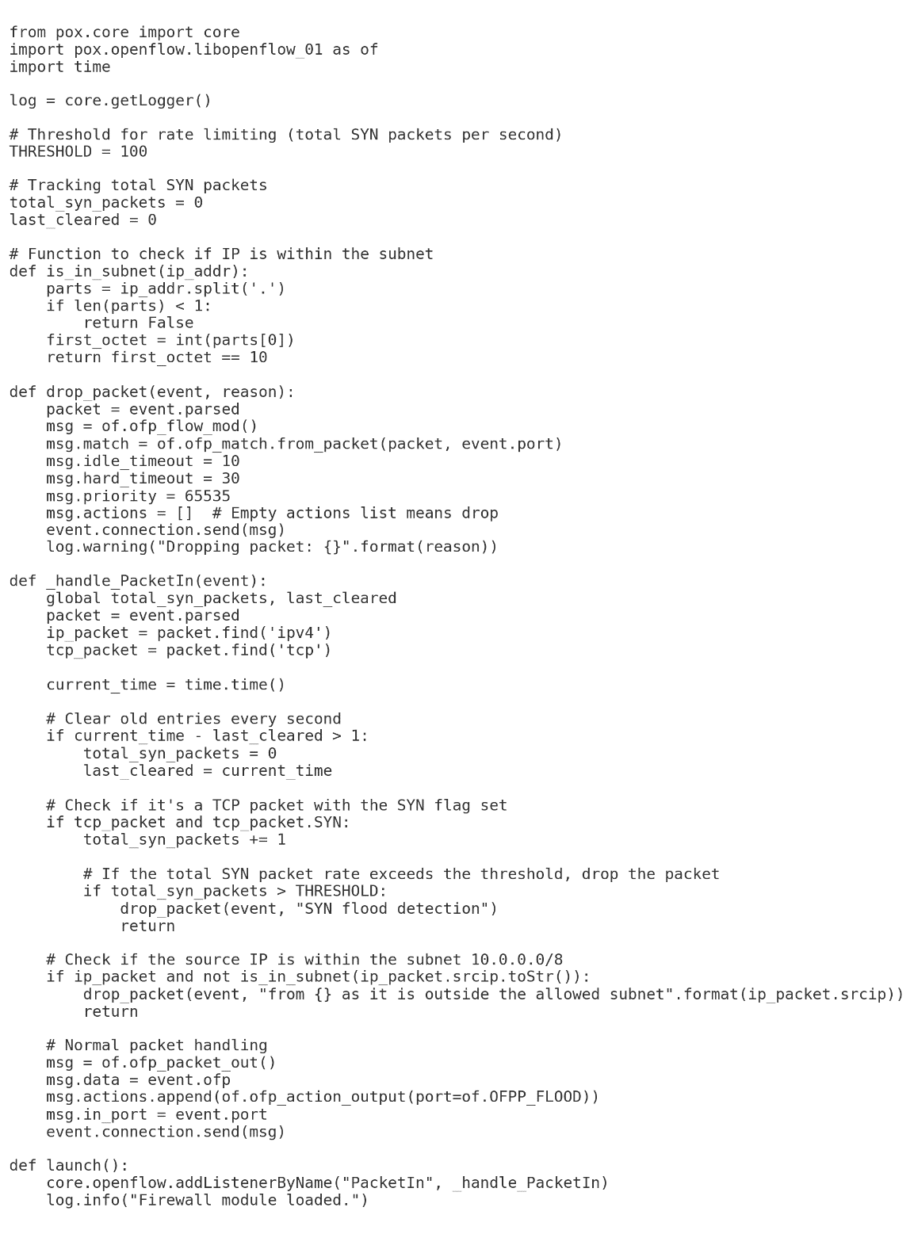

Benefits of the Proposed System:
- Enhanced Security: By filtering out malicious DoS attack traffic and restricting unauthorized access, the system safeguards the HTTP server's availability for legitimate users. This ensures uninterrupted service delivery.
- Improved Traffic Control: The SDN controller enables centralized management and configuration of the rate limiting and access control functionalities within the Python script. Network administrators can easily adjust thresholds and authorized subnets. This allows for dynamic adaptation to evolving security threats and improved overall traffic control within the network.

Results and analysis
This section analyzes the effectiveness and limitations of the proposed SDN-based system with a Python script for mitigating DoS attacks on HTTP servers.
Effectiveness Analysis:
The system offers several benefits in mitigating DoS attacks:
- Reduced Server Load: By filtering malicious traffic at the switch level, the system reduces the workload on the HTTP server, allowing it to handle legitimate requests more efficiently. This translates to improved server performance.
- Proactive DoS Mitigation: The real-time traffic analysis capabilities of the SDN controller enable proactive identification of suspicious activity. By dynamically adjusting rate limiting thresholds and access control rules within the Python script, the system can mitigate DoS attempts before they significantly impact server availability.
- Improved traffic control: The proposed them gives a high traffic control abilities as it makes you control the subnets you allow to access the web server and subnets which are not allowed, also It makes you identify the threshold of the TCP SYN packets to be sent.
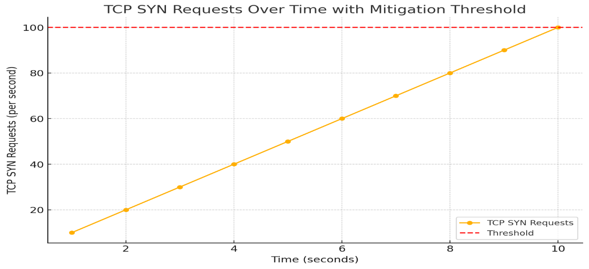

Limitations and Trade-offs:
While offering these benefits, the system also presents some limitations:
- Potential Performance Overhead: Communication between the SDN controller and switches might introduce slight delays in packet processing. While typically minimal, this overhead could be a factor in networks with real-time applications or those requiring extremely high performance. Careful configuration and resource allocation are crucial to minimizing any performance impact.
- False Positives: The system's effectiveness depends on accurately identifying malicious traffic. While rate limiting and access control offer strong protection, there's a potential for false positives. Overly restrictive settings could inadvertently block legitimate traffic. Finding the right balance between security and legitimate access is important.

conclusion and Future work
This paper presented a novel system utilizing an SDN controller and a custom Python script for mitigating DoS attacks on HTTP servers. The system leverages rate limiting and access control functionalities to filter out malicious traffic and enhance server security. By analyzing traffic patterns in real-time and dynamically adjusting security policies, the system proactively mitigates DoS attempts before they significantly impact server availability.
The proposed system offers several advantages:
- Reduced Server Burden: By filtering malicious traffic at the switch level, the system frees up server resources, improving performance and responsiveness during DoS attacks.
- Proactive Threat Mitigation: Real-time traffic analysis capabilities enable the system to identify and mitigate DoS attempts before they disrupt server operations.
- Adaptability to Evolving Threats: The Python script can be updated to address new DoS attack vectors, ensuring continued protection against emerging cyber threats.
Future research can explore further advancements to this mitigation system:
- Machine Learning Integration: Integrating machine learning algorithms into the Python script could enhance the system's ability to identify and mitigate novel DoS attack patterns. Machine learning can analyze traffic patterns and identify anomalies, allowing for proactive adjustments to security policies.
- Advanced Filtering Techniques: Investigating alternative traffic filtering techniques could potentially strengthen the system's defense capabilities against geographically distributed DoS attacks (DDoS). Techniques like dynamic blackholing or geo-filtering could be explored to further restrict access from malicious actors.
By exploring these future work directions, the proposed mitigation system can be further enhanced, providing a robust and adaptable defense against evolving DoS threats for HTTP servers.

REFERENCES
[1] H. G. Ahmed and R. Ramalakshmi, "Performance Analysis of Centralized and Distributed SDN Controllers for Load Balancing Application," 2018 2nd International Conference on Trends in Electronics and Informatics, 2018 .
[2] Thomas D. Nadeau, Ken Gray, "SDN: Software Defined Networks", O'Reilly Media, August 2013.
[3] http://ericrozner.com/papers/sdn-traceroute-hotsdn-2014-final.pdf.

